**STOCK MARKET PREDICTION**

# USING REAL TIME DATA

Enrollment Number : 9911103525

Name of Student : Rishabh Mehra

Name of supervisor : Mr. Himanshu Mittal



**June - 2015**

**Submitted in partial fulfilment of the Degree of Bachelor of Technology In Computer Science Engineering**

**DEPARTMENT OF COMPUTER SCIENCE ENGINEERING & INFORMATION TECHNOLOGY JAYPEE INSTITUTE OF INFORMATION TECHNOLOGY, NOIDA**

**(I)**

# TABLE OF CONTENTS

|  |  |  |  |  |  |  |
| --- | --- | --- | --- | --- | --- | --- |
|  | |  |  |  |  |  |
| **Chapter No.** | | **Topics** |  |  |  | **Page No.** |
|  |  |  |  |  |  |  |
|  |  | Student Declaration |  |  |  | II |
|  |  | Certificate from the Supervisor |  |  |  | III |
|  |  | Acknowledgement |  |  |  | IV |
|  |  | Summary |  |  |  | V |
|  |  | List of Figures |  |  |  | VI |
|  |  | List of Tables |  |  |  | VII |
|  |  | List of Symbols and Acronyms |  |  |  | VIII |
| **Chapter-1** |  | **Introduction** |  |  | 11-16 | |
|  |  | 1.1 General Introduction |  |  |  | |
|  |  | 1.2 Relevant current/open problems. | |  |  | |
|  |  | 1.3 Problem Statement | |  |  | |
|  |  | 1.4 Overview of proposed solution approach | | |  | |
|  |  | and Novelty/benefits | | |  | |

1.5 Comparative Study of Prediction Techniques

1.6 Details of Empirical Study

## Chapter -2 Literature Survey 17-23

2.1 Summary of papers

2.2 Integrated summary of the literature studied

## Chapter 3: Analysis, Design and Modeling 24-29

3.1 Overall description of the Project

3.2 Functional requirements

3.3 Non Functional requirement

3.4 Design Diagrams

3.4.1Use Case diagrams

3.4.2 Control Flow diagram

3.4.3 Activity diagrams

## Chapter-4 Implementation and Testing 20-38

4.1 Implementation details and issues

4.1.1 Implementation Issues

4.1.2 Proposed Algorithm

4.2 Risk Analysis and Mitigation

## Chapter-5 Testing 39-42

5.1 Testing Plan

5.2 Testing Type

5.3 Test Cases in prescribed Format

5.4 Limitations of solution

## Chapter-6 Findings & Conclusion 43-49

6.1 Findings

6.2 Conclusion

6.3 Future Work

References ACM Format (Listed alphabetically) 50

Appendices 51-54

Brief Bio-data (Resume) of Student 55-57

**(II)**

## DECLARATION

I hereby declare that this submission is my own work and that, to the best of my knowledge and belief, it contains no material previously published or written by another person nor material which has been accepted for the award of any other degree or diploma of the university or other institute of higher learning, except where due acknowledgment has been made in the text.

Place: NOIDA

Date: 03/06/2015

Signature:

Name: Rishabh Mehra Enrollment No: 9911103525

**(III)**

## CERTIFICATE

This is to certify that the work titled **"STOCK MARKET PREDICTION ”** submitted by **"** **Rishabh Mehra "** in partial fulfilment for the award of degree of B. Tech of Jaypee Institute of Information Technology University, Noida has been carried out under my supervision. This work has not been submitted partially or wholly to any other University or Institute for the award of this or any other degree or diploma.

Signature of Supervisor:

|  |  |
| --- | --- |
| Name of Supervisor: | Mr. Himanshu Mittal |
| Designation Faculty: | Professor |
| Date: | 03/06/2015 |

**(IV)**

## ACKNOWLEDGEMENT

Besides the hard work of a group, the success of a project also depends highly on the encouragement and guidelines of many others. I take this opportunity to express my sincere and heartfelt gratitude to the people who have been instrumental in the successful completion of this project.

Our first and foremost acknowledgement goes to our supervisor and mentor, **Mr. Himanshu**

**Mittal**, without whose help the completion of this project wouldn’t have been possible. It is because of his guidance and efforts that I was able to implement a practical idea based on my field of interest. I would also like to thank my panel **Mr. Shudhanshu Kulshrestha And Ms. Anubhuti Roda Mohindra**, for giving me an opportunity to present my project and for judging my work and providing me feedback which would certainly help me in the future.

Last but not the least I would like to acknowledge my institution Jaypee Institute of Information Technology for giving me a platform to give me life and implementation, to the various fields I have studied till date.

Signature:

Name: Rishabh Mehra Enrollment No: 9911103525

Date: 03/06/2015

**(V)**

## SUMMARY

Forecasting stock market prices has always been challenging task for many business analyst and researchers. In fact, stock market price prediction is an interesting area of research for investors. For successful investment lot many investors are interested in knowing about future situation of market. Effective prediction systems indirectly help traders by providing supportive information such as the future market direction. Data mining techniques are effective for forecasting future by applying various algorithms over data.

This project aims at predicting stock market by using financial news, Analyst opinions and quotes in order to improve quality of output. It proposes a novel method for the prediction of stock market closing price. Many researchers have contributed in this area of chaotic forecast in their ways. Fundamental and technical analyses are the traditional approaches so far. ANN is a popular way to identify unknown and hidden patterns in data is used for share market prediction. A multi-layered feed-forward neural network is built by using combination of data and textual mining. The Neural Network is trained on the stock quotes and extracted key phrases using the Backpropagation Algorithm which is used to predict share market closing price. This paper is an attempt to determine the NSE market news, Analyst Recommendations in combination with the historical quotes can efficiently help in the calculation of the NSE closing index for a given trading day. The highlight of this project Is that we are using REAL TIME data comprising of all 1600+ companies listed in NSE & 5000+ companies listed in BSE also including the latest data along with the last 365 days data ( Open Price, High Price, Low Price, Close Price, Volume )

__________________ __________________

Signature of Student Signature of Supervisor

Name: Mr. Himanshu Mittal

Date: 03/06/2015 Date: 03/06/2015

**(VI)**

## LIST OF FIGURES

1. Prediction Module 22
2. Use Case Diagram 26
3. Control Flow Diagram 27-28
4. Activity Diagram 29
5. Crawler Architecture 30
6. Neural Network 33
7. Analysis Graph 44
8. Screenshot of UI 45
9. Screenshot 45
10. Screenshot 46

11.Screenshot 47

12. Screenshot 48

**(VII)**

## LIST OF TABLES

1. Paper 1 17
2. Paper 2 18
3. Paper 3 19
4. Paper 4 20
5. Algorithm for a 3-layer network 36
6. Risk Analysis 37
7. Testing Plan 39
8. Test Team Details 40
9. Testing Type 40
10. Test Schedule 41
11. Test Environment 41
12. Component Decomposition 41
13. Testing Cases 42
14. Price Table HDFC 44
15. List Of top 100 Companies 51
16. Recommended Phrases 52

**(VIII)**

## LIST OF SYMBOLS & ANCRONYMS

BSE- BOMBAY STOCK EXCHANGE

NSE - NATIONAL STOCK EXCHANGE

ANN- ARTIFICIAL NEURAL NETWORK

NYSE- NEY YORK STOCK EXCHANGE

RSI - RELATIVE STRENGTH INDEX

# CHAPTER - 1 : INTRODUCTION ________________________________________________________

**1.1 General Instruction:**

Out of all the books offering investing advice to research papers analyzing mathematical prediction models, the stock market has always been centre of attraction for public and academic interest. Number of publications propose strategies with good profits, while others demonstrate the random and unpredictable behaviour of share prices. This debate on how to predict stock market recently piqued our interest and led us to choose our Major Project topic within this area of research. The following observations influenced our decision:

* There is large amount of relevant financial data available on the internet which is increasing day by day.
* Large number of C. Sc disciplines including software engineering, databases, distributed systems and machine learning have increased possibility to apply skills.
* The opportunity to expand our knowledge in finance and investing, as we had only little prior exposure to these fields.

The following sections define the goal of the project and give an overview of the system that was built.

**Basics:**

In order to clarify the goal of the project, following are the dominant schools of thought on investing must first be introduced.

## Fundamental analysis

This approach is to analyse fundamental attributes in order to identify promising companies.

This includes characteristics such as financial results, company’s assets, liabilities, and stock and growth forecasts. It’s very important to understand that this type of analysis is not static; newly released financial information, corporate announcements and other news can influence the fundamental outlook of a company. Fundamental analysis requires expertise in a particular sector and is often conducted by professional analysts. Their recommended investments are regularly published and updated.

## Technical analysis

In contrast to fundamental analysis, technical analysis does not try to gain deep insight into a company's business. It assumes the available public information does not offer a competitive trading advantage. Instead, it focuses on studying a company's historical share price and on identifying patterns in the chart. The intention is to recognize trends in advance and to capitalize on them.

## Goal

The goal was to build a system capable of the following tasks:

### 1. Collecting fundamental and technical data from the internet

The system should be able to crawl specific websites to extract fundamental data like news articles and analyst recommendations. Furthermore, it should be able to collect technical data in the form of historical share prices.

### 2. Simulating trading strategies

The system should offer ways to specify and simulate fundamental and technical trading strategies. Additionally, combining the two approaches should be possible.

### 3. Evaluating and visualizing trading strategies

The system should evaluate and visualize the financial performance of the simulated strategies. This allows a comparison to be made between technical, fundamental and the combined approaches.

Financial information sources on the Web.

1. www.yahoo.finance.com
2. Moneycontrol.com- maintain excellent electronic versions of their daily issues.
3. Reuters (www.investools.com)
4. www.nseindia.com

This rich variety of on-line information and news make it an attractive resource from which to mine knowledge. Data mining and analysis of such financial information can aid stock market predictions.

**1.2 Relevant current/open problems**.

* + - Data-are-humongous, nowadays we are seeing a rapid-explosion of numerical-stockquotes and textual-data. They are provided from all different-sources.
    - Demand forecasts are important since the basic op management process, going from the vendor raw-materials to finished goods in the customers' hands, takes some time. Most firms cannot-wait for demand to elevate and then give a reaction. Instead, they make-up their mind and plan according to future demand so-that they can react spontaneously to customer’s order as they arrive.
    - Generally, demand forecasts-lead to good-ops-and great-levels of customer satisfaction, while bad forecast will definitely-lead to costly ops and worst-levels of customer satisfaction.
    - A confusion for the forecast is the horizon, which is, how distant in the future will the forecast project? As a simple rule, the away into the future we see, the more blurry our vision will become -- distant forecasts will be inaccurate that short-range forecasts.

### 1.3 Problem statement

As we discussed problems above we are going to implement the following:

* In this project, we-are trying to review the possibility to apply two-known techniques which is neural-network and data-mining in stock market prediction. Extract useful information from a huge amount of data set and data mining is also able to predict future trends and behaviors through neural network. Therefore, combining both these methods could make the prediction much suitable and reliable.
* The most important for predicting stock market prices are neural networks because they are able to learn nonlinear-mappings between inputs and outputs.
* It may be possible to perform better than traditional analysis and other computerbased methods with the neural-networks ability to learn-nonlinear, chaotic-systems.

### 1.4 Overview of proposed solution approach

* Basically the main objective of this project is to collect the stock information for some previous years and then accordingly predict the results for the predicting what would happen next. So for we are going to use of two well-known techniques neural network and data mining for stock market prediction. Extract useful information from a huge amount of data set and data mining is also able to predict future trends and behaviors through neural network. Therefore, combining both these techniques could make the prediction more suitable and much more reliable.
* As far as the solutions for the above problems, the answer depends on which way the forecast is used for. So the procedures that we will be using have proven to be very applicable to the task of forecasting product demand in a logistics system. Many techniques, which can prove useful for forecasting-problems, have shown to be inadequate to the task of demand forecasting in logistics systems.

**Novelty/Benefits**:

The rich variety of on-line information and news make it an attractive resource from which one can get data. Stock market predictions can be aided by data mining and analysis of such financial information.

Numerical stock quotes collected from yahoo finance and reuters.com are available in organised manner but we have to apply some techniques to parse textual news information about **Indian stock market** is collected from websites released daily.

* 1. **Comparative Study of Prediction Techniques Table 9.**

|  |  |  |  |  |
| --- | --- | --- | --- | --- |
| **Criteria** | **Technical Analysis** | **Fundamental**  **Analysis** | **Traditional**  **Time Series**  **Analysis** | **Machine**  **Learning**  **Techniques** |
| **Data Used** | Price, volume,highest, lowest prices | Growth, dividend payment, sales level, interest rates, tax rates etc. | Historical data | Set of sample data |
| **Learning methods** | Extraction of trading rules from charts | Simple trading rules extraction | Regression analysis on attributes is used | Inductive learning is used |
| **Type of Tools** | Charts are used | Trading rules | Simple  Regression and Multivariate analysis used for time series. | Nearest neighbor and Neural Networks are used |
| **Implementatio**  **n** | Daily basis prediction | Long –term basis prediction | Long –term basis prediction | Daily basis prediction |

* 1. **Details of Empirical Study:**

**Collection of Stock quotes, Analyst Advice and News:**

The information of stock-market is collected once-a-day for the companies in NSE-&-BSE with-a-database of 1 year.

1. NSE-&-BSE Stock-Index-Dataset: The released data on financial-websites is-divided into two-part numerical-quotes & textual-format news-data.
2. It’s collected from yahoo-finance; they are available-on-sites at all the time as in .csv file.
3. Historical-prices of the quotes of stocks-and the daily-published-news are collected.
4. Recommendations of-the-analysts are collected-and analysed collectively.

**Numerical Representation**

Quotes of stocks-are-normalized by scaling-down its unit so-they-occur in small-ranges of 0.0. to 1.0 .These values-that-are-normalized are input values for the-attributes in the tuplesof-training so that to fasten the learning-phase.

**News Documents Pre-processing**

Pre-processing has a unit which is used-to-process the non-structured news-documents. A priori-domain-knowledge is fed up such as .txt-files of stop-words such as an, the, a, of etc. The module of prediction compromises greatly trained many-layered feed-forward-neuralnetwork. Back-propagation is an algorithm-of-learning for neural-network. Speaking roughly, a neural-network is the connected-input-and-output sets of unit in which each-conn has weight-attached with it. During the learning phase, the network-learns by changing-theweights so that correct-class-label of the input-tuples can be predicted

**CHAPTER - 2 : LITERATURE SURVEY**

# ________________________________________________________

## 2.1 Summary of Papers

### 2.2.1

|  |  |
| --- | --- |
| ***Title*** | **Predicting Stock Trends through Technical Analysis and Nearest Neighbor Classification** |
| ***Authors*** | Lamartine Almeida Teixeira  Adriano Lorena Inácio de Oliveira  Department of Computing Systems  University of Pernambuco  Recife, Brazil |
| ***Year of***  ***Publication*** | February 2009 |
| ***Publishing details*** | IEEE International Conference on Systems, Man, and Cybernetics Conference on Systems, Man, and Cybernetics |
| ***Summary*** | Tech Examination, is built on the philosophies of the Dow Theory and practises the past of prices to forecast upcoming actions. The method used in tech examination can be enclosed as a outline credit problem, where the ideas are resulting from the history of values and the output is an estimate of the price or an estimate of the prices trend. The most significant evidence of this type of examination is that the marketplace action reductions everything. It means the specialist believes that anything that can perhaps affect the marketplace is already reflected in the prices, as well as that all the new evidence will be directly reflected in those prices. As a import, all the technician needs is to analyse the past of prices The main gears of the tech examination are the capacity and price charts. Based on the data of values and size the tech pointers are built. Tech pointers are math formulations that are applied to the price or volume statistics of a safekeeping for demonstrating some aspect of the association of those amounts. |
| ***Web Link*** | [http://ieeexplore.ieee.org/xpl/articleDetails.jsp?tp=&arnumber=53459 44&queryText%3Drsi+stock](http://ieeexplore.ieee.org/xpl/articleDetails.jsp?tp=&arnumber=5345944&queryText%3Drsi+stock) |

### 2.2.2

|  |  |
| --- | --- |
| ***Title*** | **Improving N Calculation of the RSI Financial Indicator Using Neural Networks** |
| ***Authors*** | Alejandro Rodríguez-González, Fernando Guldris- Iglesias, Ricardo Colomo-Palacios  Giner Alor-Hernandez, Ruben Posada-Gomez  Computer Science Department  Universidad Carlos III de Madrid  Leganés, Spain |
| ***Year of***  ***Publication*** | January , 2010 |
| ***Publishing details*** | 2010 International Journal on Recent and Innovation Trends in  Computing and Communication, Volume |
| ***Summary*** | There has been growing interest in Trading Decision Support Systems in recent years. In spite of its volatility, it is not entirely random, instead, it is nonlinear and dynamic or highly complicated and volatile. Stock movement is affected by the mixture of two types of factors: determinant (e.g. gradual strength change between buying side and selling side) and random (e.g. emergent affairs or daily operation variations).  There are 3 modules that are talked about in this research paper. The Neural Network Module is the responsible of provide the N values that are used to calculate RSI and decide if an investor should invest in a certain company.  Trading system Module analyzes the result given by neural network module. When a query is formulated to the system, it takes the actual values of the market and builds a query to the neural network. If RSI value is higher than 70 the decision that trading system return is a sell signal. If RSI value is lower than 30 the decision that trading system return is a buy signal.  The heuristic module is in charge of managing the different formulas that provide the heuristic used to generate the optimal values for RSI indicator. |
| ***Web Link*** | [http://ieeexplore.ieee.org/xpl/articleDetails.jsp?tp=&arnumber=56092 52&queryText%3Drsi+stock](http://ieeexplore.ieee.org/xpl/articleDetails.jsp?tp=&arnumber=5609252&queryText%3Drsi+stock) |

### 2.2.3

|  |  |
| --- | --- |
| ***Title*** | **Stock Trend Prediction Using Simple Moving Average Supported by News Classification** |
| ***Authors*** | Stefan Lauren  Dra. Harlili S., M.Sc.  Informatics Engineering  Bandung Institute of Technology  Bandung, Indonesia stefan.lauren@yahoo.com |
| ***Year of***  ***Publication*** | October , 2014 |
| ***Publishing details*** | 2014 International Conference of Advanced Informatics: Concept,  Theory and Application (ICAICTA) |
| ***Summary*** | Simple moving average is one of many time series analysis technique. Time series analysis is a method of timely structured data processing to find statistics or important characteristics for many reasons. Simple moving average shows stock trend by calculating the average value of stock prices on specific duration. The prices that are used are closing prices at the end of the day. This technique can avoid noises and therefore smooth the trend movement.    The main objective of financial news classification is to classify and calculate each news’ sentiment value. Positive news are marked by sentiment value which is greater than 0, while negative news are marked by less than 0 sentiment value. If there are news having 0 sentiment value, they will be omitted as their neutralism does not affect the stock trend.    Machine learning using artificial neural network algorithm is used to predict stock trend. The artificial neural network uses three features along with one label. The three features are simple moving average distance which is a subtraction of long-term and short-term simple moving average, total value of positive sentiment value for one day news, and total value of negative sentiment value for one day news. Stock trend label is used and classified as uptrend and downtrend. On one hand, learning component is done by background process. On the other hand, prediction component is foreground process which is seen and interact with the user. |
| ***Web Link*** | [http://ieeexplore.ieee.org/xpl/articleDetails.jsp?tp=&arnumber=7005 929&queryText%3Dmoving+average+stock](http://ieeexplore.ieee.org/xpl/articleDetails.jsp?tp=&arnumber=7005929&queryText%3Dmoving+average+stock) |

### 2.2.4

|  |  |
| --- | --- |
| ***Title*** | **Does the use of Technical & Fundamental Analysis improve Stock Choice?** |
| ***Authors*** | Carol Hargreaves  Yi Hao  Institute of Systems Science  National University of Singapore  Singapore, School of Business Economics  Wilfrid Laurier University  Waterloo, Canada |
| ***Year of***  ***Publication*** | December, 2009 |
| ***Publishing details*** | Proceedings of 2009 12th International Conference on Computer and Information Technology (ICCIT 2009) |
| ***Summary*** | A stock market is a private or public market for the trading of company stock and derivatives of company stock at an agreed price. Many financial companies such as stock markets produce large datasets and are looking to find efficient ways to discover useful information about stocks and the market for investment decisions. The prediction of stock prices using data mining techniques applied to technical variables has been widely researched but not much research to date has been done in applying data mining techniques to both technical and fundamental information. In order to have a systemized approach for the selection of stocks and a high likelihood of the performance of the stock price increasing, a Data Mining Approach is applied. |
| ***Web Link*** | [http://ieeexplore.ieee.org/xpl/login.jsp?tp=&arnumber=6396537&url](http://ieeexplore.ieee.org/xpl/login.jsp?tp=&arnumber=6396537&url=http%3A%2F%2Fieeexplore.ieee.org%2Fiel5%2F6384622%2F6396508%2F06396537.pdf%3Farnumber%3D6396537)  [=http%3A%2F%2Fieeexplore.ieee.org%2Fiel5%2F6384622%2F63](http://ieeexplore.ieee.org/xpl/login.jsp?tp=&arnumber=6396537&url=http%3A%2F%2Fieeexplore.ieee.org%2Fiel5%2F6384622%2F6396508%2F06396537.pdf%3Farnumber%3D6396537)  [96508%2F06396537.pdf%3Farnumber%3D6396537](http://ieeexplore.ieee.org/xpl/login.jsp?tp=&arnumber=6396537&url=http%3A%2F%2Fieeexplore.ieee.org%2Fiel5%2F6384622%2F6396508%2F06396537.pdf%3Farnumber%3D6396537) |

## 2.2 Integrated Summary

The most interesting task is to predict the market. So many methods are used for completing this task. Methods, vary from very informal ways to many formal ways a lot. These tech. are categorized as Prediction Methods, Traditional Time Series, Tech Analysis Methods, Mach Learning Methods and Fundamental Analysis Methods. The criteria to this category is the kind of tool and the kind of data that these methods are consuming in order to predict the market. What is mutual to the technique is that they are predicting and hence helping from the market's future behaviour.

**Technical Analysis Methods**:

Method of guessing the correct time to vend or purchase a stock pricing. The reason behind tech analysis is that share prices move in developments uttered by the repetitively altering qualities of investors in answer to different forces. The tech data such as price, volume, peak and bottom prices per trade-off period is used for graphic representation to forecast future stock activities.

**Fundamental Analysis Techniques**:

This practice uses the theory of firm foundation for preferred-stock selection. Data of fundamental analysis can be used by forecasters for using this tech of prediction for having a fully clear idea about the market or for investment. The growth, the bonus pay out, the IR, the risk of investing so on are the standards that will be used to get the real value for an asset in which they could finance in the market. Main target of this process is to determine an inherent value of an strength.

**Traditional Time Series Prediction:** Past data is used here and it uses this data to find coming values for the time series as a linear grouping. Use of Regression depictions have been used for forecasting stock market time series. Two rudimentary types of time series are simple and multivariate regressions.

**Machine Learning Methods:**

The main reason is inductive learning. These type of methods use samples of data that is needed for creating an hope for the underling function that had produced all of the other data. Taking out a deduction from different samples which are given to the model is the main aim for this. The Nearest Neighbour and the Neural Networks Practices have been used for forecasting of the market.

## Prediction Module

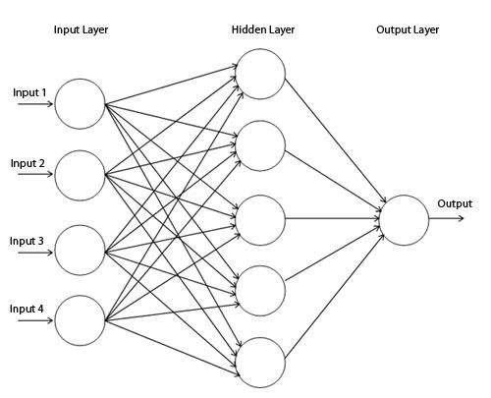

**Multi-layered Feed-Forward network**

This neural network has one layer of input, concealed layer, and one yield layer.

**Input layer:** Made up of units; the qualities measured for each drill tuple matches to the input to the network. Inputs are served to this layer instantaneously. The input passes through input layer and weighted & instantaneously served to the next layer i.e.

hidden layer.

**Hidden Layer:** The productions of the input layer are input to this concealed layer. The number of concealed layer is random; in rehearsal only one concealed layer is used. The weighted output of the concealed layer are input to the next or output layer, which actually releases the network forecast for given tuples.

**Output Layer:** This layer actually discharges the network forecast for given tuples. Multilayer feed forward network are able to model the class forecast as a nonlinear grouping of the input. For given concealed units and enough preparation samples can carefully estimate to any function

# . CHAPTER 3 : ANALYSIS, DESIGN & MODELING ________________________________________________________

## 3.1 Overall description of the project

Project is overall based upon the myraid data which is going to be mined from various stock related portals and after fetching the desired data they have been used for the predictions of related results.

### Collection of Stock quotes

We are collecting the stock information once in day.

1. BSE Stock Index Dataset: The data released over financial websites is in both the forms like numerical quotes and textual format news data.
2. It is collected from yahoo/finance; they are available on sites at all the time as in .csv file.
3. Historical prices of the stock quotes are collected.
4. Stock quotes are normalized by scaling its units so they occur in small range of 0.0. to 1.0 . To speed up the erudition phase these normalized values are used as put in values for each feature in the training tuples.

**News Documents Preprocessing:**

To process unstructured news documents the Pre-processor unit is used. It is fed up with a priori field knowledge such as .txt files of stop words such as a, an, the, of etc.

The following steps involved in pre-processor unit are as follows:

1. Stop Words Removal
2. Stemming
3. Key Phrases Extraction.

These key phrases are initiated with some weight .Lastly, The system assessment on the stocks from India’s Bombay Stock Exchange is carried out. For given day’s open index, day’s high, day’s low, volume and adjacent values along with the stock news textual data, our forecaster will forecast the final index price for given trading date.

**3.2 FUNCTIONAL REQUIREMENTS:**

The prediction shall abide by the following functional requirements:

* + - 1. Prior to application of stock recommendations, the database is updated by the latest values.
      2. The charts and comparison of the companies would be done only on the latest data stock market data.
      3. The user is provided with a login, logging into which enables the user to view his past stock purchases and future recommendations.
      4. The user can look previous data Information which was collected.
      5. Each user has a friend list and can also be recommended on their buying patterns.
      6. The user can also be recommended on the basis of the trending stocks which would require the data regarding the stocks.

**3.3 NON FUNCTIONAL REQUIREMENTS:**

* + 1. **Reliability**: The reliability of the product will be dependent on the accuracy of the data- date of purchase, how much stock was purchased, high and low value range as well as opening and closing figures. Also the stock data used in the training would determine the reliability of the software.

* + 1. **Security:** The user will only be able to access the website using his login details and will not be able to access the computations happening at the back end.

* + 1. **Maintainability:** The maintenance of the product would require training of the software by recent data so that there commendations are up to date. The database has to be updated with recent values.

* + 1. **Portability:** The website is completely portable and the recommendations completely trustworthy as the data is dynamically updated.

* + 1. **Interoperability:** The interoperability of the website is very high because it synchronize all the database with the wamp server.

**3.4 Design Diagrams**

## 3.4.1 USE CASE DIAGRAM

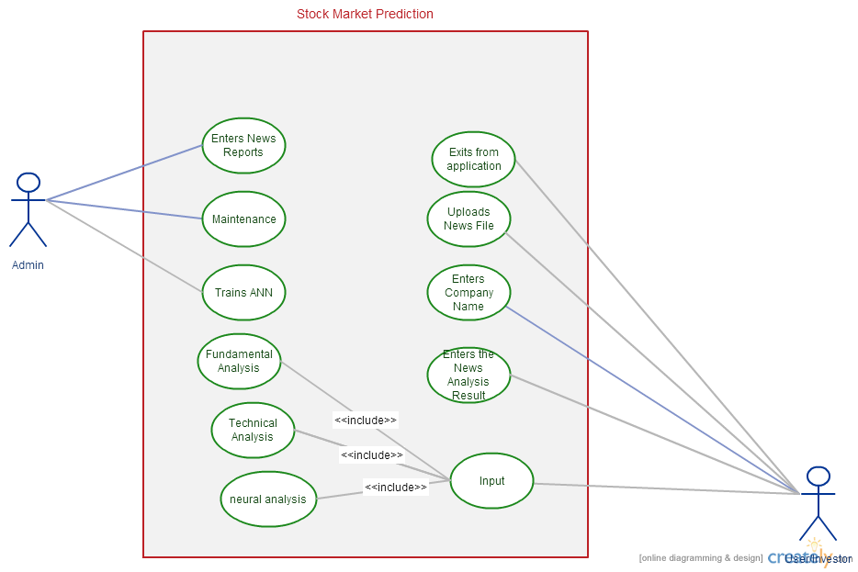

**3.4.2 CONTROL FLOW DIAGRAM**

## Overall Control Flow Diagram

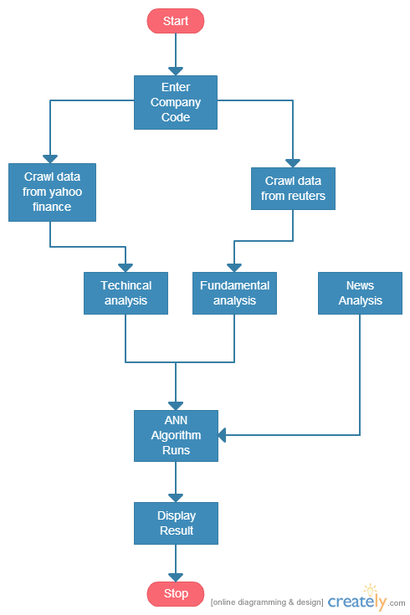

ANN Control Flow Diagram

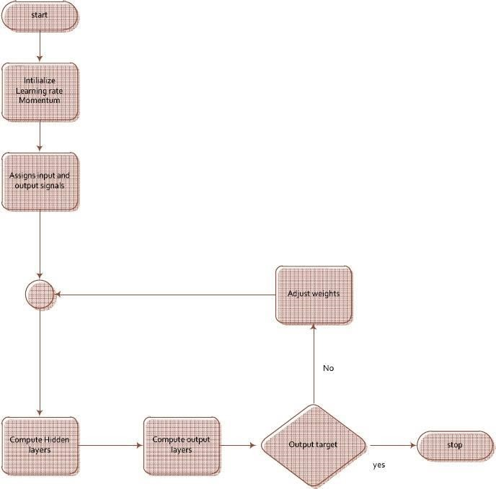

## 3.4.3 ACTIVITY DIAGRAM

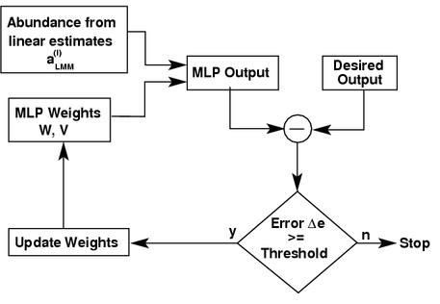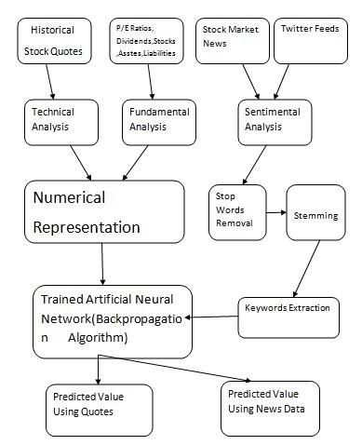

**[11]**

# CHAPTER 4 : IMPLEMENTATION AND TESTING _______________________________________________________

**4.1 Implementation Details and Issues:**

## The Crawler - Data Sources

In the early phase, a large no. of websites were considered and the ones most appropriate for the project were identified. The following sections outline characteristics of each data source and list some examples. Data Source - Type URL

Moneycontrol → News Fundamental moneycontrol.com

Reuters '→ Reuters Finance Analyst Recommendations

Yahoo Finance → Historical Prices Technical finance.yahoo.com

Yahoo's financial portal includes current and past analyst recommendations for each company. This makes it possible to track the changing sentiment of analysts by following the upgrades and downgrades over time.

Yahoo Finance Historical Prices

After analyzing Yahoo Finance, Yahoo's historical stock quotes were selected. The quotes which are selected consists of daily opening, low, high and closing prices and are adjusted for stock splits and dividends. The other sources were also more desirable, but was abandoned because of periods of missing prices and some price inconsistencies when compared to services like Yahoo and Google.

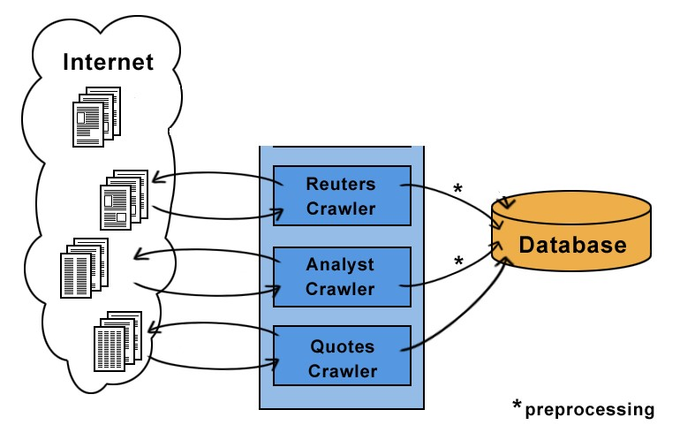

The quotes crawler does not need this phase, as Yahoo's historical quotes are conveniently available in CSV format.

## Parsing analyst recommendations

Different research firms tend to use different vocabulary for recommendations. For example, some use Market Outperform, while others use Over-weight or simply Buy to suggest a buying opportunity. In order to compare recommendations, all 96 different phrases found in the dataset were manually mapped to the three expressions Buy, Neutral and Sell. Appendix B lists the various phrases and their mappings.

## Computing Trading Signals

The fundamental and technical signals for the evaluating companies are described. A company is deemed potential when all the specified signals point out a rising price trend. Accordingly, a company is deemed failing when all specified signals predict a downward price trend.

Typically, several companies meet the criteria on a given day.

## Analyst Recommendations

Due to the pre-processing, the analyst recommendations were easily comparable across research firms. Thus, they could be aggregated to an analyst sentiment. At any given time, the number of analysts recommending Buy, Neutral or Sell could be computed (nBuy, nNeutral and nSell accordingly). This resulted in the following signal:

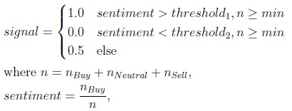

The values threshold1 and threshold2 represent levels of analyst sentiment that must be met to trigger buy or sell signals; e.g. selecting a value of 0.7 for threshold1 means 70% of the analysts must be recommending a Buy. The parameter min specifies the least number of analysts required to compute a signal.

## Technical Trading Signals

The technical analysis in detail is covered by the book 'New Trading Systems and Methods'. After studying the book, 2 out of four technical signals seemed promising and were implemented: 1. Moving Average

1. Moving Average Convergence Divergence
2. Relative Strength Index
3. Stochastic

To give the reader a favour of technical analysis, the Moving Average and RSI will be explained in the subsequent sections.

## Moving Average

A moving average is a effortless technique to recommend buying and selling points on a stock price chart. For this purpose, the mean share price in a trailing window is calculated. Common values for the window size are 20 days, 60 days and 200 days. When the present prices rise beyond the moving average, a procure signal is triggered. A sell signal is triggered when the present price comes down below the moving average.

With pt symbolizing the share price at time t, a moving average signal can simply be expressed as:

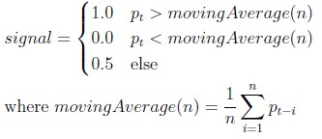

## Combining Trading Signals

A trading strategy can use one or more of the signals. When using more than one signal, a scheme for combining them is required. The following sections describe the two possible combination techniques that were implemented.

## Simple Combinations

A simple way to combine the output of several signals is to only signal a buy or sell when all specified signals do so. This can be expressed as follows:

1.0 if all individual signals return 1.0 signal (combined) = 0.0 if all individual signals return 0.0

0.5 else

## Combinations using Neural Networks

Using historical data, a neural network can be learned that describes how trading signals are related to subsequent price movements. Figure shows how the implemented fundamental and technical signals can be used as input values and how the expected future price trend is the desired output. The trained neural network can then be used on new data to forecast future price movements and make investments. Details are explained in the following sections.

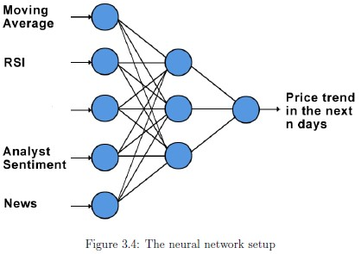

The input values are all normalized to the continuous [0,1] range.

## Output

The output is the expected price change in a window of days. The value is in the continuous [0,1] range with 1.0 representing a 10% rise, 0.5 representing no price change and 0.0 representing a 10% price drop.

## Training

The neural network's weights are learned using the backpropagation algorithm with a configurable learning rate and number of epochs.

## Trading

Once a neural network is built, it can be used by inserting current technical and fundamental input values and computing the predicted output value. If the output crosses a certain upper threshold (e.g: 0.7), an upward price trend can be predicted and shares can be bought. Likewise, a descending price tendency can be signalized by an yield value below a lower cut-off value and short-selling can take place.

**4.1.2 Proposed Algorithm**

The study used three-layer (one hidden layer) multilayer feed-forward neural network model taught with backpropagation algorithm.

**Backpropagation**, an abbreviation for "backward propagation of errors", is a common technique of teaching artificial neural networks used in combination with an optimization method such as gradient descent. The method calculates the gradient of a loss function with respects to all the weights in the network. The gradient is fed to the optimization method which in turn uses it to apprise the weights, in an attempt to minimalize the cost function

The backpropagation learning algorithm can be divided into two phases: propagation and weight update.

**Phase 1: Propagation**:

“Each propagation involves the following steps:

1. Onward propagation of a training pattern's input through the neural network in order to create the propagation's output initiations.
2. Backward propagation of the propagation's output activations through the neural network using the training pattern target in order to generate the summation of all output and concealed neurons.”

**Phase 2: Weight update:**

For each weight-synapse follow the following steps:

1. Multiply its output summation and input activation to get the gradient of the weight.
2. Subtract a ratio (percentage) of the gradient from the weight.

This proportion (percentage) influences the speediness and worth of learning; it is called the *learning rate*. The bigger the ratio, the quicker the neuron trains; the lesser the ratio, the more precise the training is. The sign of the gradient of a weight specifies where the fault is increasing, this is why the weight must be updated in the opposite direction.

Repeat phase 1 and 2 until the performance of the network is satisfactory.

**Algorithm for a 3-layer network (only one hidden layer**):

|  |
| --- |
| initialize network weights (often small random values)  **do** **forEach** training example ex  prediction = neural-net-output(network, ex) *// forward pass*  actual = teacher-output(ex)  compute error (prediction - actual) at the output units  compute  for all weights from hidden layer to output layer *// backward pass*  compute for all weights from input layer to hidden layer *// backward pass continued*  update network weights *// input layer not modified by error estimate*  **until** all examples classified correctly or another stopping criterion satisfied  **return** the network |

## 4.2 Risk Analysis and Mitigation Plan

1. Since, we are making software which involves updations/modifications, heavy computations and to and-fro activity may be required. But, the software should never take more than reasonable amount of time, which is the goal of the project. Although, it’s a risk if it takes much time.

Probability: Low (1)

Impact: High (5)

1. There are light and background constraints for the application. Due to unavailability of resources or server, we might not be able to use the application.

Probability: High (5)

Impact: High (5)

1. We will never be able to check if our code is upto the requirement, for complex objects, as we will have to update/ modify time to time. Although, this risk can be reduced by machine learning by implementing automatic database updating of new scanned objects.

Probability: Low (1)

Impact: High (5)

**5. Testing and requirement analysis**

|  |
| --- |
| SOFTWARE REQUIREMNTS:  Netbeans Java IDE  Yahoo.Finance Price Crawler  Windows 7 OS  Xampp Server  MySql Databse  Video Maker Software |
| HARDWARE REQUIREMENTS :  Laptops  CD  LAN wire  Soft Bound Report |

### Component decomposition and type of testing required

|  |  |  |  |
| --- | --- | --- | --- |
| **S No.** | List of Various  Components  (modules) that require testing | Type of Testing Required | Technique for writing test cases |
| 1 | Data (Stock Price) | Requirement | Black Box(Boundary Values) |
| 2 | Algorithms (BP) | Unit | White Box |
| 3 | Neural Network (output | Unit | White Box |
| 4 | Graphs and Table | Volumes | White Box |

## 

**5.3: Limitations of the Solutions**

The solution has a few limitations which are relevant to the proper functioning of our application:

1. Parsing research firms :Several notations were being used for the same research firm (e.g. CSFB and CS First Boston). A map was manually created to ensure the different expressions were mapped to the same firm.

1. Parsing analyst recommendations: Different research firms tend to use different vocabulary for recommendations. For example, some use use Over-weight or simply buy to suggest a buying opportunity. In order to compare recommendations, all 96 different phrases found in the dataset were manually mapped to the three expressions Buy, Neutral and Sell.

1. When working on a large project, small bugs can creep in and easily go unnoticed for some time (e.g. array indices of by one). Particularly when running simulations, the results may be greatly affected and the error may be hard to track down. In order to prevent this to a certain extent, unit tests were written using the JUnit4 framework. The behaviour of all relevant simulation server classes could be checked; when refactoring parts of the server, the behaviour could be revalidated.

# CHAPTER 6: FINDINGS AND CONCLUSIONS ________________________________________________________

**6.1 Findings:**

The system evaluation on the stocks from India’s Bombay Stock Exchange & NSE is carried out. For given day’s open index, day’s high, day’s low, volume and adjacent values along with the stock news textual data, our forecaster will forecast the closing index value for particular trading day.

Our predictive model is evaluated on NSE market on the financial historical stock data over the training period of June 2014 to May 2015. The news data is collected from the financial web sites http://www.finance.yahoo.com, http://reuters.com and www.moneycontrol.com. The news data is collected once in day. The stock quotes corresponding to each trading day were downloaded from http://finance.yahoo.com.

The accuracy of the system is measured as the percentage of the predictions that were correctly determined by the system. For instance, if the system forecasts an upward trend and the index indeed goes up, it is supposed to be correct, otherwise, if the index goes down or remains stable for an uptrend, it is assumed to be wrong.

Following stock dataset is taken as sample training data of HDFC over the period of 22 days. Corresponding rates file is also provided along with this. Predictions using stock quotes are shown .Whenever the desired predictions using quotes are varying from actual one, we rebuilt neural network by considering the news data of that day.

### 6.2 CONCLUSION

Evaluating the Stock market prediction has at all times been tough work for analysts. Thus, we attempt to make use of vast written data to forecast the stock market indices. If we join both techniques of textual mining and numeric time series analysis the accuracy in predictions can be achieved. Artificial neural network is qualified to forecast BSE market upcoming trends. Financial analysts, investors can use this prediction model to take trading decision by observing market behaviour.

### 6.3 FUTURE WORK

* More work on refining key phrases extraction will definitely produce better results. Enhancements in the preprocessor unit of this system will help in improving more accurate predictability in stock market.
* Twitter feeds message board, Extracting RSS feeds and news.
* Considering internal factors of the company likes Sales, Assets etc.

**References**

[1 ]Daily Stock Market Forecast from Textual Web Data

W• uthrich, B.; Cho, V.; Leung, S.; Permunetilleke, D.; Sankaran, K.; Zhang, J.; Lam, W.

IEEE International Conference on Systems, Man, and Cybernetics, vol.3, pp.2720-2725 vol.3, 11-14 Oct 1998

1. The Apache httpclient library is an open source Java library for working with HTTP.

*http://hc.apache.org/httpcomponents-client*/

1. NekoHTML is an open source Java library for fixing HTML. *http://nekohtml.sourceforge.net*

1. The Text Mining Handbook: Advanced Approaches in Analyzing Unstructured Data Ronan Feldman and James Sanger Cambridge University Press, 11 Dec 2006

1. New Trading Systems And Methods Perry J. Kaufman Wiley, 4th Edition, 28 Feb 2005

1. Stock Market Prediction with Backpropagation Networks Freislben, B. Industrial and

Engineering Applications of Artificial Intelligence and Expert Systems, vol.604, pp.451-460, 1992

1. An Intelligent Forecasting System of Stock Price Using Neural Networks

Baba, N.; Kozaki, M. International Joint Conference on Neural Networks, vol.1, pp.371- 377, 1992

# Appendix A

**TOP 100 NSE-BSE listed companies Symbols**

|  |  |
| --- | --- |
| [TCS](http://www.moneycontrol.com/india/stockpricequote/computerssoftware/tataconsultancyservices/TCS) | [Bosch](http://www.moneycontrol.com/india/stockpricequote/autoancillaries/bosch/B05) |
| [ITC](http://www.moneycontrol.com/india/stockpricequote/cigarettes/itc/ITC) | [Hero Motocorp](http://www.moneycontrol.com/india/stockpricequote/auto23wheelers/herohondamotors/HHM) |
| [ONGC](http://www.moneycontrol.com/india/stockpricequote/oildrillingandexploration/oilnaturalgascorporation/ONG) | [Bharti Infratel](http://www.moneycontrol.com/india/stockpricequote/auto23wheelers/herohondamotors/BI14) |
| [Reliance](http://www.moneycontrol.com/india/stockpricequote/refineries/relianceindustries/RI) | [Nestle](http://www.moneycontrol.com/india/stockpricequote/foodprocessing/nestleindia/NI) |
| [Coal India](http://www.moneycontrol.com/india/stockpricequote/miningminerals/coalindia/CI11) | [NMDC](http://www.moneycontrol.com/india/stockpricequote/miningminerals/nmdc/NMD02) |
| [SBI](http://www.moneycontrol.com/india/stockpricequote/bankspublicsector/statebankindia/SBI) | [GAIL](http://www.moneycontrol.com/india/stockpricequote/oildrillingandexploration/gailindia/GAI) |
| [HDFC Bank](http://www.moneycontrol.com/india/stockpricequote/banksprivatesector/hdfcbank/HDF01) | [Dr Reddys Labs](http://www.moneycontrol.com/india/stockpricequote/pharmaceuticals/drreddyslaboratories/DRL) |
| [Infosys](http://www.moneycontrol.com/india/stockpricequote/computerssoftware/infosys/IT) | [Idea Cellular](http://www.moneycontrol.com/india/stockpricequote/telecommunicationsservice/ideacellular/IC8) |
| [ICICI Bank](http://www.moneycontrol.com/india/stockpricequote/banksprivatesector/icicibank/ICI02) | [Adani Enterpris](http://www.moneycontrol.com/india/stockpricequote/trading/adanienterprises/AE13) |
| [HDFC](http://www.moneycontrol.com/india/stockpricequote/financehousing/housingdevelopmentfinancecorporation/HDF) | [Cipla](http://www.moneycontrol.com/india/stockpricequote/pharmaceuticals/cipla/C) |
| [Sun Pharma](http://www.moneycontrol.com/india/stockpricequote/pharmaceuticals/sunpharmaceuticalindustries/SPI) | [BPCL](http://www.moneycontrol.com/india/stockpricequote/refineries/bharatpetroleumcorporation/BPC) |
| [HUL](http://www.moneycontrol.com/india/stockpricequote/personalcare/hindustanunilever/HU) | [Bank of Baroda](http://www.moneycontrol.com/india/stockpricequote/bankspublicsector/bankofbaroda/BOB) |
| [Tata Motors](http://www.moneycontrol.com/india/stockpricequote/autolcvshcvs/tatamotors/TM03) | [Cairn India](http://www.moneycontrol.com/india/stockpricequote/oildrillingandexploration/cairnindia/CI37) |
| [Bharti Airtel](http://www.moneycontrol.com/india/stockpricequote/telecommunicationsservice/bhartiairtel/BA08) | [IndusInd Bank](http://www.moneycontrol.com/india/stockpricequote/banksprivatesector/indusindbank/IIB) |
| [Larsen](http://www.moneycontrol.com/india/stockpricequote/diversified/larsentoubro/LT) | [Eicher Motors](http://www.moneycontrol.com/india/stockpricequote/autolcvshcvs/eichermotors/EM) |
| [Wipro](http://www.moneycontrol.com/india/stockpricequote/computerssoftware/wipro/W) | [Dabur India](http://www.moneycontrol.com/india/stockpricequote/personalcare/daburindia/DI) |
| [Axis Bank](http://www.moneycontrol.com/india/stockpricequote/banksprivatesector/axisbank/AB16) | [United Spirits](http://www.moneycontrol.com/india/stockpricequote/breweriesdistilleries/unitedspirits/US) |
| [NTPC](http://www.moneycontrol.com/india/stockpricequote/powergenerationdistribution/ntpc/NTP) | [Power Finance](http://www.moneycontrol.com/india/stockpricequote/financetermlendinginstitutions/powerfinancecorporation/PFC02) |
| [HCL Tech](http://www.moneycontrol.com/india/stockpricequote/computerssoftware/hcltechnologies/HCL02) | [PNB](http://www.moneycontrol.com/india/stockpricequote/bankspublicsector/punjabnationalbank/PNB05) |
| [Maruti Suzuki](http://www.moneycontrol.com/india/stockpricequote/autocarsjeeps/marutisuzukiindia/MS24) | [Motherson Sumi](http://www.moneycontrol.com/india/stockpricequote/autoancillaries/mothersonsumisystems/MSS01) |
| [Kotak Mahindra](http://www.moneycontrol.com/india/stockpricequote/banksprivatesector/kotakmahindrabank/KMB) | [Zee Entertain](http://www.moneycontrol.com/india/stockpricequote/mediaentertainment/zeeentertainmententerprises/ZEE) |
| [IOC](http://www.moneycontrol.com/india/stockpricequote/refineries/indianoilcorporation/IOC) | [Tata Steel](http://www.moneycontrol.com/india/stockpricequote/steellarge/tatasteel/TIS) |
| [M&M](http://www.moneycontrol.com/india/stockpricequote/autocarsjeeps/mahindramahindra/MM) | [Ambuja Cements](http://www.moneycontrol.com/india/stockpricequote/cementmajor/ambujacements/AC18) |
| [UltraTechCement](http://www.moneycontrol.com/india/stockpricequote/cementmajor/ultratechcement/UTC01) | [Oil India](http://www.moneycontrol.com/india/stockpricequote/oildrillingandexploration/oilindia/OI13) |
| [Power Grid Corp](http://www.moneycontrol.com/india/stockpricequote/powergenerationdistribution/powergridcorporationindia/PGC) | [SAIL](http://www.moneycontrol.com/india/stockpricequote/steellarge/steelauthorityindia/SAI) |
| [Asian Paints](http://www.moneycontrol.com/india/stockpricequote/paintsvarnishes/asianpaints/AP31) | [Titan Company](http://www.moneycontrol.com/india/stockpricequote/miscellaneous/titanindustries/TI01) |
| [Bajaj Auto](http://www.moneycontrol.com/india/stockpricequote/auto23wheelers/bajajauto/BA10) | [Aurobindo Pharm](http://www.moneycontrol.com/india/stockpricequote/pharmaceuticals/aurobindopharma/AP) |
| [Hind Zinc](http://www.moneycontrol.com/india/stockpricequote/metalsnonferrous/hindustanzinc/HZ) | [REC](http://www.moneycontrol.com/india/stockpricequote/financetermlendinginstitutions/ruralelectrificationcorporation/REC02) |
| [Adani Ports](http://www.moneycontrol.com/india/stockpricequote/engineering/mundraportspecialeconomiczone/MPS) | [Shree Cements](http://www.moneycontrol.com/india/stockpricequote/cementmajor/shreecements/SC12) |
| [Lupin](http://www.moneycontrol.com/india/stockpricequote/pharmaceuticals/lupin/L) | [Godrej Consumer](http://www.moneycontrol.com/india/stockpricequote/personalcare/godrejconsumerproducts/GCP) |
| [BHEL](http://www.moneycontrol.com/india/stockpricequote/engineeringheavy/bharatheavyelectricals/BHE) | [Hindalco](http://www.moneycontrol.com/india/stockpricequote/aluminium/hindalcoindustries/HI) |
| [Sesa Sterlite](http://www.moneycontrol.com/india/stockpricequote/miningminerals/sesagoa/SG) | [Cadila Health](http://www.moneycontrol.com/india/stockpricequote/pharmaceuticals/cadilahealthcare/CHC) |
| [Tech Mahindra](http://www.moneycontrol.com/india/stockpricequote/computerssoftware/techmahindra/TM4) | [Yes Bank](http://www.moneycontrol.com/india/stockpricequote/banksprivatesector/yesbank/YB) |
|  |  |

[Siemens](http://www.moneycontrol.com/india/stockpricequote/telecommunicationsequipment/siemens/S)

[Grasim](http://www.moneycontrol.com/india/stockpricequote/diversified/grasimindustries/GI01)

[Oracle Fin Serv](http://www.moneycontrol.com/india/stockpricequote/computerssoftware/oraclefinancialservicessoftware/OFS01)

[ABB](http://www.moneycontrol.com/india/stockpricequote/electricequipment/abb/ABB)

[Pidilite Ind](http://www.moneycontrol.com/india/stockpricequote/chemicals/pidiliteindustries/PI11)

[GlaxoSmithKline](http://www.moneycontrol.com/india/stockpricequote/pharmaceuticals/glaxosmithklinepharmaceuticals/GSK)

[Ranbaxy Labs](http://www.moneycontrol.com/india/stockpricequote/pharmaceuticals/ranbaxylaboratories/RL)

[ACC](http://www.moneycontrol.com/india/stockpricequote/cementmajor/acc/ACC06)

[Container Corp](http://www.moneycontrol.com/india/stockpricequote/transport/containercorporationindia/CCI)

[JSW Steel](http://www.moneycontrol.com/india/stockpricequote/steellarge/jswsteel/JSW01)

[IDFC](http://www.moneycontrol.com/india/stockpricequote/financetermlendinginstitutions/infrastructuredevelopmentfinancecompany/IDF)

[Shriram Trans](http://www.moneycontrol.com/india/stockpricequote/financeleasinghirepurchase/shriramtransportfinancecorporation/STF)

[Castrol](http://www.moneycontrol.com/india/stockpricequote/lubricants/castrolindia/CI01)

[GlaxoSmith Con](http://www.moneycontrol.com/india/stockpricequote/foodprocessing/glaxosmithklineconsumerhealthcare/GSC04)

[DLF](http://www.moneycontrol.com/india/stockpricequote/constructioncontractingrealestate/dlf/D04)

[Colgate](http://www.moneycontrol.com/india/stockpricequote/personalcare/colgatepalmoliveindia/CPI)

[Cummins](http://www.moneycontrol.com/india/stockpricequote/engines/cumminsindia/CI02)

[Divis Labs](http://www.moneycontrol.com/india/stockpricequote/pharmaceuticals/divislaboratories/DL03)

[Bharat Elec](http://www.moneycontrol.com/india/stockpricequote/electricals/bharatelectronics/BE03)

[Tata Power](http://www.moneycontrol.com/india/stockpricequote/powergenerationdistribution/tatapowercompany/TPC)

[United Brewerie](http://www.moneycontrol.com/india/stockpricequote/breweriesdistilleries/unitedbreweries/UB02)

[Bharat Forge](http://www.moneycontrol.com/india/stockpricequote/castingsforgings/bharatforge/BF03)

[LIC Housing Fin](http://www.moneycontrol.com/india/stockpricequote/financehousing/lichousingfinance/LIC)

[AB Nuvo](http://www.moneycontrol.com/india/stockpricequote/textilesmanmade/adityabirlanuvo/ABN01)

[Britannia](http://www.moneycontrol.com/india/stockpricequote/foodprocessing/britanniaindustries/BI)

[Marico](http://www.moneycontrol.com/india/stockpricequote/personalcare/marico/M13)

[Glenmark](http://www.moneycontrol.com/india/stockpricequote/pharmaceuticals/glenmarkpharma/GP08)

[Bajaj Finserv](http://www.moneycontrol.com/india/stockpricequote/financeinvestments/bajajfinserv/BF04)

[NHPC](http://www.moneycontrol.com/india/stockpricequote/powergenerationdistribution/nhpc/N07)

[Canara Bank](http://www.moneycontrol.com/india/stockpricequote/bankspublicsector/canarabank/CB06)

[Bank of India](http://www.moneycontrol.com/india/stockpricequote/bankspublicsector/bankofindia/BOI)

[Reliance Comm](http://www.moneycontrol.com/india/stockpricequote/telecommunicationsservice/reliancecommunications/RC13)

[P and G](http://www.moneycontrol.com/india/stockpricequote/personalcare/proctergamblehygienehealthcare/PGH)

[Torrent Pharma](http://www.moneycontrol.com/india/stockpricequote/pharmaceuticals/torrentpharmaceuticals/TP06)

# Appendix B Recommendation Phrases

The following 96 phrases were found in the analyst recommendations dataset.

|  |
| --- |
| **Buy**  Above Average, Accumulate, Add, Attractive, Buy, Buy Aggressive, Buy Speculative, IT Outperform, LT Accum, LT Accumulate, LT Attractive, LT Buy, LT Mkt Out- performer, LT Outperform, LT Strong Buy, Market Outperform, Mkt Outperform, Mkt Outperformer, Net Positive, NT Accum, NT Accum/LT Accum, NT Accum/LT  Buy, NT Accumulate, NT Buy, NT Buy/LT Buy, NT Buy/LT Strong Buy, NT Mkt  Outperformer, NT Outperformer, NT Strong Buy, NT Strong Buy/LT Strong Buy,  NT/LT Accum, NT/LT Buy, NT/LT Outperformer, NT/LT Strong Buy, Outperform,  Outperform/Buy, Over Weight, Overweight, Positive, Recomm List, Recomm: List,  Recommended List, SB, Sector Outperform, Speculative Buy, ST Buy, ST Buy/LT  Buy, Strong Buy, Strong Buy Aggress, Strong Buy Spec, Top Pick |
| Neutral  Average, Equal Weight, Equal-weight, Hold, In-line, IT Mkt Perform, LT Market Perform, LT Mkt Performer, LT Mkt Perforn, Maintain, Maintain Position, Mar- ket Perform, Market Weight, Mkt Perform, Neutral, NT Mkt Performer, NT Mkt Prfm/LT Outprfm, NT Neutral, NT Neutral/LT Buy, NT Reduce/LT Neut, NT/LT Mkt Performer, NT/LT Ntrl, Peer Perform, Perform, Sector Perform, ST Mkt Per- form, ST Mkt Perform/LT Mkt Perform, Under Review |
| Sell  Avoid, Below Average, Market Underperform, Mkt Underperform, Negative, NT  Reduce-Sell/LT Neutral, NT Reduce/Sell, Reduce, Sector Underperform, Sell, ST  Avoid, ST Avoid/LT Avoid, Strong Sell, Unattractive, Under Weight, Underperform,  Underweight |

Analyst recommendation phrases

# Appendix C Research Papers Analyst Based Prediction

Below is a list of the relevant research papers that were studied; they are sorted chronologically and accompanied by a short summary.

## 1998. Daily Stock Market Forecast from Textual Web Data

This paper is credited as the first to mine online news for market prediction. To begin, a list of influential phrases (e:g: 'bond strong') was created by domain experts. Probabilistic rules based on the frequency of the terms appearing in news articles are learned using the last 100 days of data. The rules are then applied to current news articles in order to predict the next day's movement of several stock indices (up, steady or down). The best classification accuracy that was achieved was 46.7%. A follow-up paper[16] extends the approach by combining several news sources.

## 2000. Language Models for Financial News Recommendation

This approach tries to filter out the most relevant articles from a stream of news. This is done by associating historical news with five types of stock price trends and building a Bayesian classifier for terms. A trading strategy based on the classification achieved a gain of 0.23% per trade.

**2002. News Sensitive Stock Trend Prediction.**

This approach attempts to classify news articles into the three categories rise, drop and neutral.

Text classification is achieved with Support Vector Machines (SVM).

**Appendix D**

# Technical Trading Signals

## Relative Strength Index (RSI)

The Relative Strength Index indicates an overbought/oversold situation. It is based on cumulating the upward and downward price movements in a window. Low RSI values suggest an oversold situation and suggest a buy signal. High RSI values suggest a sell signal.

1.0 RSI(n) < 0:3 signal= 0.0 RSI(n) > 0:7

0.5 else

where RSI(n) = RS(n)

1 + RS(n)

RS(n) = total upward price movements in the last n days

total downward price movements in the last n days

**Rishabh Mehra** mehra.rishabh13@gmail.com

Mob. No. 9716737707

**Career objective:**to utilize my educational background and further augment my practical exposure to become an asset for the organization.

**Professional Qualifications:**

|  |  |  |  |
| --- | --- | --- | --- |
| .B.Tech CSE | PURSUING-  VII  Semester | 2011-  2015 | From Jaypee Institute of Information And  Technology,Noida |

**Academic Qualifications:**

|  |  |  |  |
| --- | --- | --- | --- |
| 10 + 2 | 79% | 2011 | Central Board of Secondary Education |
| 10th | 87% | 2009 | Central Board of Secondary Education |

**Computers** **Skills:**

MS-Office (Word, Excel, PowerPoint),Adobe Photoshop

Languages known-C,C++,Unix

Web development

**Extra Curricular Activity:**

* Participated In Interschool CBSE cluster for Kho-Kho, BasketBall.
* Attended workshop on Ethical Hacking organised by Byte Code Cyber Security in Delhi Technical University.
* Worked as a Team Member for AIESEC IN DELHI IIT

Was a part of various events organised by AIESEC IN DELHI IIT like the Global Humanism Summit 2013,Youth To Buisiness Forum etc.

Project Training

-

Student, HCL Career Development Centre **Jun 2013 – Jul 2013** ➢ I completed a 6 Weeks Training Course in Core Java.

**Minor Project in Software Engineering and Web Technologies** ➢ Developed a social networking website based on books.

**Minor Project in Information Security**

* Developed a dual password email account technique with added layer of email encryption.

**Jun 2014 – Jul**

**Industrial Training at CMC Limited 2014**

* I completed a 6 Weeks Training in Advanced Java.

**Personal Profile:**

**Name** Rishabh Mehra

**Permanent Address** III-E 181 Nehru Nagar Ghaziabad-201001

.ph no.-0120-2796430

**Date of Birth** 13-February 1993

**Father’s name** Mr. Ajay Mehra

**Languages Known** English, Hindi,Punjabi

**Traits;**

I am a very hardworking and dedicated individual.

I am amiable and of adjusting nature.

I like to face challenges and whatever task I take I never leave that half way.

I am truthful, straightforward and honest person.

Date:17th Sept 2014